CREED
We, the homemakers of Wisconsin, believe in the sanctity of the HOME, the cradle of character, blessed by motherly devotion and guarded by fatherly protection.
WE PLEDGE ourselves —
To work for the preservation and improvement of home and community life:
To strive for healthier minds and bodies and better living:
To promote the welfare of our boys and girls, the nation’s greatest asset:
To be true to God and country and of lasting service to our homes and communities.
~ Mrs. John Meise, Sauk County

PRAYER
Dear God, give us the grace to see
The blessings which have come from Thee:
Give us strength to do our duty,
To see in everything some beauty;
Teach us that love and cheerful giving,
Tolerance and decent living,
Make of our home a place sublime
Where there’s no room for hate or crime,
A place where good friends gather round.
Where laughter, mirth and cheer abound,
Not selfish thoughts nor worldly greed,
Let this, Dear Master, be our Creed.
~ Mrs. James M. Hutton, St. Croix County

Home and Community Education
Program Directory
2023

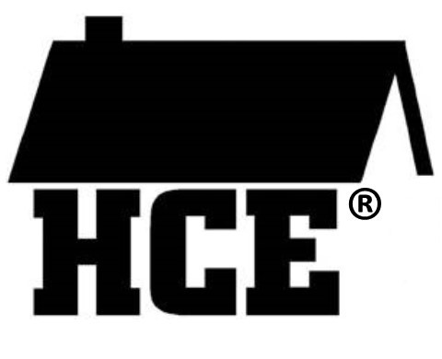

New way of living with HCE

Name_______________________
Club ________________________

Address changes
New Members
Meeting Minutes

Dues ($10) (October 31)

Please mail or contact:

Phoebe Shourds
401 State Road 65,
River Falls, WI 54022
pnpaulson@yahoo.com
715-821-1606 Cell

Mission Statement:
“HCE Working Together Can Create Positive Change.
“Let’s Continue to Make it Happen”.

NOTES
_____________________________________________________________________________________________________________________________________________________________________________________________________________________________________________________________________________________________________________________________________
Volunteer Hours:
Description | Hours | $ Spent
i.e. Club Meetings
Club Meeting – Jan
Club Meeting – Feb
Club Meeting – Mar
Club Meeting – Apr
Club Meeting – May
Club Meeting – Aug
Club Meeting – Sept
Club Meeting – Oct
Club Meeting – Nov
Club Meeting – Dec
Worked at Fair – July
District Mtg – Spring
District Mtg – Fall
Special Projects

Club Organization
President
Vice President
Secretary
Treasurer

Club Member | Phone | Birthday

Suggested Order of Business

Creed
Pledge
Roll Call

Business Meeting
- Secretary Report
- Treasurer Report

Reports (Marketing, Membership, Cultural Arts, International, Bookworms, Scholarship)

Old Business

New Business

Any Other Business

Project presentation for the month (Optional)

Prayer
Record Education Program Activities
Send copy of meeting minutes to:
Phoebe Shourds – 401 State Road 65
River Falls, WI 54022
Or email to: pnpaulson@yahoo.com

Update Subscriptions
($8.00) _____ One Year or
($15.00) _____ Two Years
______ New Subscriber
______ Renewal UPDATE

Name _________________________________________

County _______________________________________

Address ______________________________________

City __________________________________________

State __________

Zip_______________ +4 ___________

Check ______; Check Number __________

Cash __________

Date __________

Please make check payable to: WAHCE, Inc.
Mail subscription and payment to:
Marcelline Protheroe, Update Editor
N6131 22nd Drive
Wild Rose, WI 54984
State / District Officers:
State President— Eileen Gottbeheat, 17007 Hoover Road, Tomah, WI 54660 608-374-2261 gottbeheatfarms@gmail.com
State Treasurer—Louise Dahlke, 5781 S. Cty Road T, Denmark 53910 920-362-4756 lddahlke47@gmail.com
State Membership— Charlene Southworth, 234 Main Street, North Prairie WI 53153 charart46@gmail.com
State Secretary—Bernie Arena, 4261 Basswood Road, Sparta, WI 54656 608-272-3371 bernadine.arena@gmail.com
Dist. Director NW— Phoebe Shourds 401 State Road 65, River Falls 54022; 715-821-1606 pnpaulson@yahoo.com
Dist. Membership— Jennifer Raddatz PO Box 145, Turtle Lake, 54889 715-541-2384 jenniferraddatz2772@gmail.com
Dist. Marketing—Wanda Breitbach, 879 220th Ave., Somerset 54025; 715-248-3806(h) 612-719-6017©
Dist. Secretary—Kristy Sand, 963 85th Ave, Cty Rd H, Amery 54001 715-554-1349 kcants@hotmail.com
Dist. Treasurer—Cheryl McCuskey 1121 S Business Hwy 53, Solon Springs 54873; 715-378-4450 dmccuske@centurytel.net
Dist. Cultural Arts—Julie D’ Angelo, E5602 690th Ave, Menomonie 54751 715-962-13386 Minds.eye.enterprises@gmail.com
Dist. Intl—Jean Kelley 1429 130th Ave., New Richmond, 54017 612-229-5591 jeanekelley07@hotmail.com

WI Bookworms Coordinator—Elaine Villeneuve N6977 430th St., Menomonie 54751; 715-235-3656 vilnev@wwt.net AND Karen Scheibe 12895 Birchwood Rd., Drummond 54832; 715-739-6632
Update Editor—Marcelline Protheroe N6134 22nd Drive; Wild Rose 54984; 920-622-3959 proth@centurytel.net

Extension St Croix County WI

Tim Skutley—Area Extension Director 715-977-2936
Ryan Sterry—Regional Dairy Educator 715-531-1950
Michael Geissinger–-Regional Crops Educator 651-
302-6520
Sky Holt—4-H Program Educator 715-531-1938
Katie Bartko—Nutrition Coordinator 715-531-1934
Karen Frantti—Nutrition Educator 715-531-1507
Diana Alfuth—Horticulture Educator 715-273-6781
Selena Freimark—Health and Well-Being Educator
715-531-1947
Kari Weiss—Community Development Educator 715-
531-1941
Laura Hinz—Outreach Support Associate
(laura.hinz@wisc.edu) 715-531-1937
St. Croix County UW-Extension
Agricultural Service and Education Center
1960 8th
Ave., Suite 140
Baldwin, WI 54002
Phone: 715-531-1930 Fax: 715-684-2666
https://stcroix.extension.wisc.edu/
Hours: 8:00 am—4:30 pm

January 2023
Meeting Date: _______________

Hostess: ___________________

Place: ___________________________

Time : _______________

Contribution Hours: _________________________

Contribution Dollars: ________________________

Date | Event | Time | Location
1 | UPDATE Britelites
10 | Exec Board Mtg | 2 – 3:30 | Ag Center

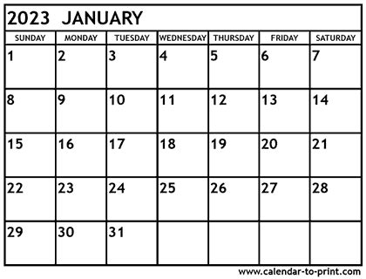

St. Croix County Executive Board Members
President, Linda Sutherland, 1594 5th Ave., Star Prairie, 54026; 715-338-9214; hattieclaire23@yahoo.com

President-Elect, Vacant

Secretary, Stephany Bourdon, 1870 80th St., Balsam Lake, 54810; 715-245-3266; thomasbourdon@att.net

Treasurer, Phoebe Shourds, 401 State Road 65, River Falls, 54022; 715-821-1606© pnpaulson@yahoo.com

Scholarship, Phoebe Shourds – 401 State Road 65, River Falls, 54022

Marketing (County and District), Wanda Breitbach, 879 220th Ave., Somerset, 54025; 715-248-3806(h) 612-719-6017©

Cultural Arts, Lois Burri/Char Croes/Carol Kobernick, 2215 Hwy 46, Deer Park, 54007; 715-269-5145; jccroes@amerytel.net

Membership, Jennifer Raddatz PO Box 145, Turtle Lake, 54889 715-541-2384 jenniferraddatz2772@gmail.com

International and International WNP,
Jean Kelley (W N/P), 1429 130th Ave., New Richmond, 54017; 612-229-5591 or 715-246-5591 (H); jeanekelley07@hotmail.com

Melodee Sortedahl W356 N 2nd Apt 5, Spring Valley 54767 715-440-8052 msortedahl@yahoo.com

Wisconsin Bookworms/Readers Coordinators, Betty Lee, 203 Solum Dr., Woodville, 54028; 715-698-2832 mamalee203@gmail.com and
Shirley Grinley, 471 270th, Woodville, 54028; 715-698-2325 grinleysg@yahoo.com

Fair Representative, Phoebe Shourds (see above)

St. Croix County Clubs & Presidents or Contacts

Deer Park—Lori Peterson, 6285 130th St. Amery 54007; 402-936-5723 (3rd Thursday at 6:30 pm)

Honey Doers—Lynda Johnson, N8157 Cty Road B, Spring Valley 54767; 715-772-4230 (2nd Wednesday at 1:30 pm)

McKinley—Carol Keller, 1085 Trout Brook Rd., Hudson, 54016; 715-386-8244 (Meeting time varies)

Pleasant Grove— Roxanne Lund, 390 Cty Rd BB, Woodville, 54028 715-684-3936 (3rd Thursday at 2:00pm)

Warren – Stephany Bourdon, 1870 80th St. Balsam Lake, 54810 (no set date) 715-245-3266

Woods ‘n Hills—Presidents; Liz Doyone, 1623 Namekagon St #35, Hudson, 54016; 715-386-3470 (2nd Wednesday at 1:00 pm)

* For individual member’s contact information, please contact Phoebe Shourds 715-821-1606 or Wanda Brietbach at 715-248-3806 *

Wanda Breitbach 715-248-3806 | JoLane Anderson 612-889-7788
Jennifer Raddatz 715-541-2384 | Phoebe Shourds 715-821-1606
Kay Walsh | Linda Sutherland
Janis Annis 715-643-2442 | Junalee Hoganson 715-265-4701
Jean Kelley 715-246-5591

February 2023

Meeting Date: _______________

Hostess: ___________________

Place: ___________________________

Time : _______________

Discussion Topic: _______________________

Date | Event | Time | Location
16 | Spud Spectacular | 11:30 | Ag Center

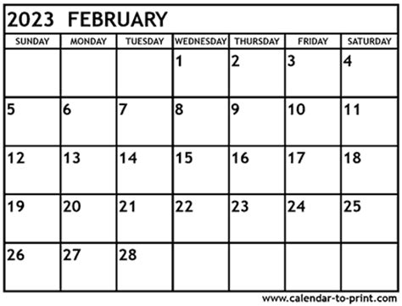

March 2023

Meeting Date: __________________________

Hostess: ________________________________

Place: ___________________________________

Time : ___________________________________

Discussion Topic: _______________________

Date | Event | Time | Location
14 | Executive Board Mtg | 2 pm | Ag Center

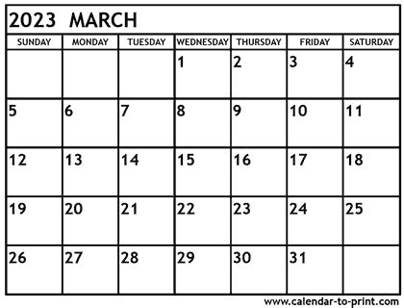

December 2023

Meeting Date: _______________

Hostess: ___________________

Place: ___________________________

Time : _______________

Discussion Topic: _______________________

Date | Event | Time | Location

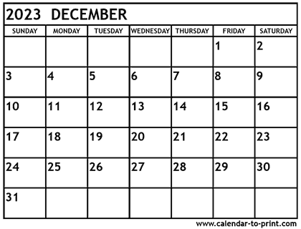

November 2023

Meeting Date: _______________

Hostess: ___________________

Place: ___________________________

Time : _______________

Discussion Topic: _______________________

Date | Event | Time | Location
7 | Potluck/Planning | 12:00 | Ag Center
15 | Meet & Greet | 11:30 | Pump House Downing
15 | Orange the World – Wear Orange |  | On your own

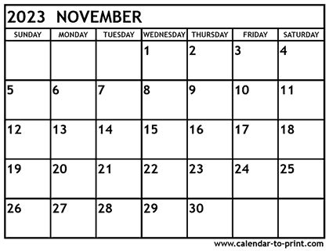

April 2023

Meeting Date: _______________

Hostess: ___________________

Place: ___________________________

Time : _______________

Discussion Topic: _______________________

Date | Event | Time | Location
26 | Meet and Greet | 11:30 | Deers Bar
27 | Spring District | 11am | Joy Lutheran Polk Cty
28 | Spring Council  Honey Doers Hosting | 10-3 | Hammond Town Hall

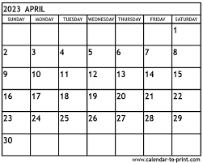
May 2023

Meeting Date: _______________

Hostess: ___________________

Place: ___________________________

Time : _______________

Discussion Topic: __________________________

Date | Event | Time | Location
9 | Executive Board | 2 pm | Ag Center
24 | Meet & Greet | 11:30 | West Winds (RF)
17 | ACWW Triennial |  | Kuantan Malaysia

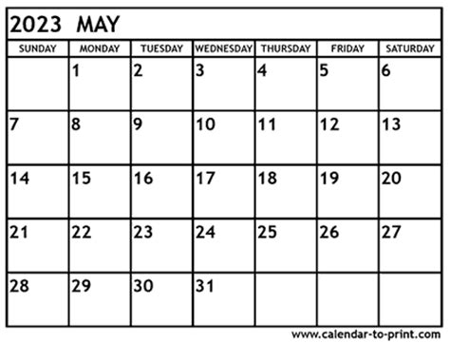
October 2023

Meeting Date: _______________

Hostess: ___________________

Place: ___________________________

Time : _______________

Discussion Topic: _______________________

Date | Event | Time | Location
1 | Fall District | 2:pm | Zoom
5 | Fall Council/Intl | 12pm | Deer Park Comm Ctr
12 | Tour | 10-4 | Dresser/Orchard
25 | Meet & Greet | 11:30 | Azul Tequila (NR)
31 | Dues due to Treasurer |  | Provide list of members, Officer Positions

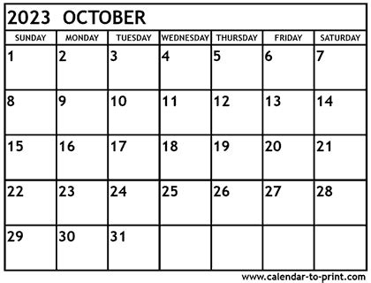
September 2023

Meeting Date: _______________

Hostess: ___________________

Place: ___________________________

Time : _______________

Discussion Topic: _______________________

Date | Event | Time | Location
12 | Executive Board | 2 pm | Ag Center
17-20 | State Conference |  | Wisc Dells
27 | Meet & Greet | 11:30 | Kingdom Buffet

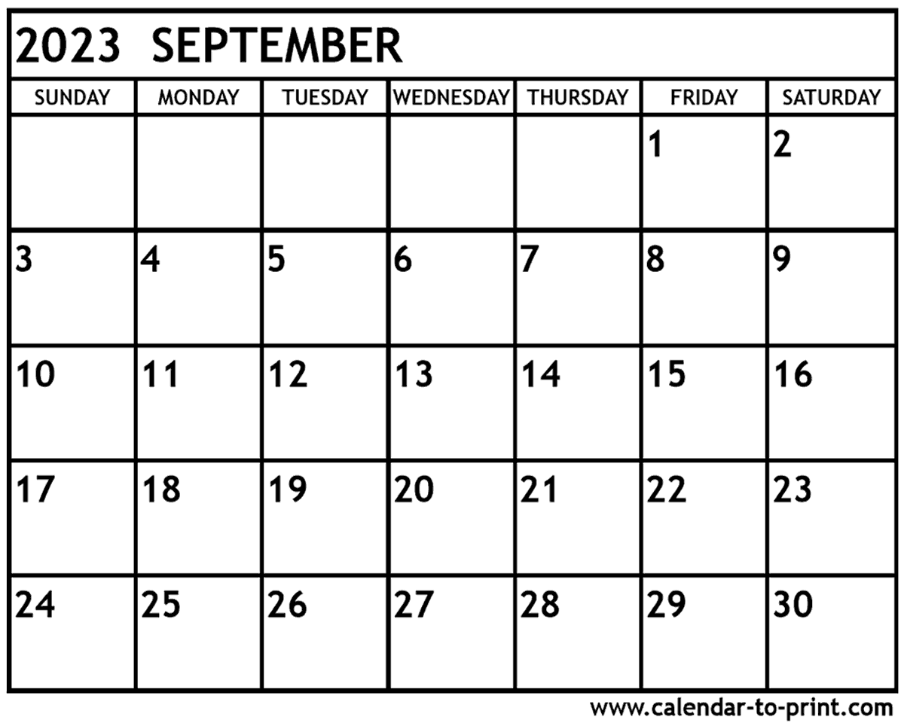

June 2023

Meeting Date: _______________

Hostess: ___________________

Place: ___________________________

Time : _______________

Discussion Topic: _______________________

Date | Event | Time | Location
15 | Special – Pollinators | TBD | Ext or NR Legion
28 | Meet and Greet | 11:30 | Jewel Town (SP)

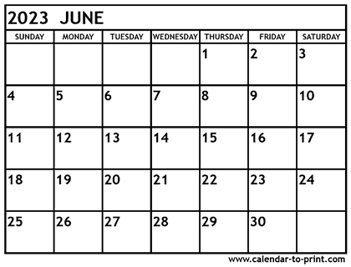

July 2023

Meeting Date: _______________

Hostess: ___________________

Place: ___________________________

Time : _______________

Discussion Topic: _______________________

Date | Event | Time | Location
11 | Executive Board | 2 pm | Ag Center
19-23 | St. Croix Cty Fair | 9 – 9 | Glenwood City
18-20 | NVON |  | Parkersburg, WV
26 | Meet & Greet | 11:30 | Barnboard

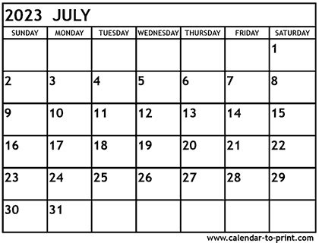

August 2023

Meeting Date: _______________

Hostess: ___________________

Place: ___________________________

Time : _______________

Discussion Topic: _______________________

Date | Event | Time | Location
1 | Cultural Arts Items Due
8 | Special Int – Move |  | Hudson TBD
23 | Meet & Greet | 11:30 | Woodville Cafe

